Efficient LED EGC1 7” headlamp, backed up by a certificate of approval, is now available

The lamp that off-road enthusiasts have long been waiting for has arrived on the shelves. The company WESEM has extended its driving lamp portfolio to include a waterproof 4-function headlamp that fully embraces LED technology. As it is an equivalent product in relation to multiple 7-inch lights, this headlamp can be used on all-terrain vehicles, motorcycles as well as American classic cars.

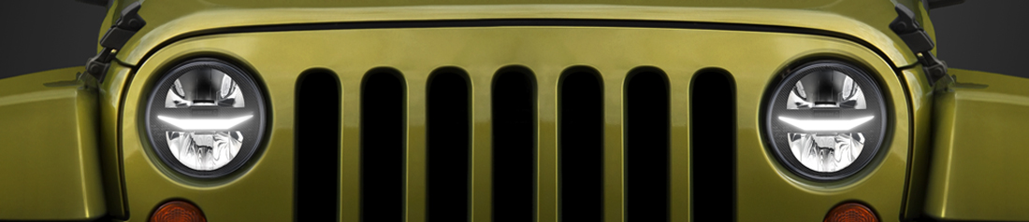

The company WESEM, a Polish manufacturer, has been steadily extending its LED product range. At the Automechanika automotive trade show in Frankfurt its new LED EGC1 headlamp was premiered.

“For years now, all-terrain vehicle users have been enquiring about our LED product offering for their vehicles. By showing their appreciation for the quality of our halogen lamps, which they had been buying for years and which they still use, they motivated us to further develop our LED lamps range for their cars. As you can see, that worked. We take pride in our modern products which drivers are not afraid of using in extreme conditions or long-distance treks, where proper lighting is necessary to ensure safe and comfortable driving.” – says Tomasz Hajduk, a WESEM shareholder.

To date, WESEM's most popular additional LED lamps, appreciated by all-terrain vehicle users, include:
- driving lamps: FERVOR 180, FERVOR 220, CDC3,
- work lamps: LEDF, CRV2, CRP1,
- CRK2-AR reversing lamps.

Now this Polish manufacturer has launched an exceptional new product: a 4-function built-in LED headlamp, available in 7 inch size which is often found in vehicles. This modern headlamp, with low power consumption, features 4 light functions:
- low beams – 11 W,
- high beams – 11 W,
- position lights – 1,4 W,
- daytime running lamps (DRL) – 5,5 W.
It is the daytime running lights (DRL) that are most often used - they consume only 5,5 W!
The high-beam light, with reference mark 17,5, reaching ca. 270 m, allows the driver to provide optimum illumination for the road ahead and ensure comfortable driving conditions. As the headlamp can operate in the high-beam and low-beam mode at the same time (the headlamp has HCR approval), the driver can enjoy even a larger field of view.

This is what you can expect from the headlamp:
- attention to detail,
- durable materials,
- solid design.

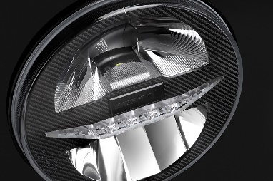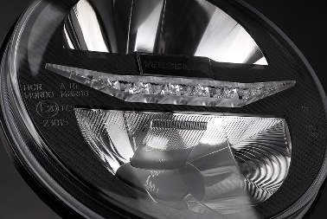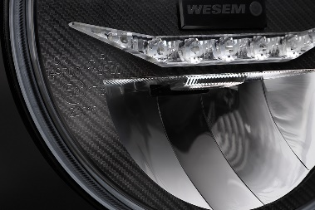

EGC1 is a built-in headlamp dedicated for many car makes: Jeep Wrangler: TJ (97-06), CJ7 (76-86), JK (07-17), Land Rover Defender (since 1983), Łada: Niva 2121, Niva 2131, Mazda MX-5 (89-98), Suzuki Samuraj SJ (81-98), Chevrolet Camaro (70-81), Ford Mustang (73-81), Jaguar XJ (68-92) and all the other cars where a 7-inch lamp will fit. The headlamp is intended for mounting in factory-designed holes or spaces, or for incorporating in front recesses on your vehicle.
The headlamp is positioned within the medium price range. It is a perfect alternative both for pioneering new headlamps and cheap replacement lamps which fall far below the driver's expectations in terms of grade and quality.

The headlamp, which has just been launched, has the following code:
EGC1.55400

The manufacturer says that there are more surprises to come this year:
“We are working on finishing the much expected LED-bar. It will be available as a few versions, with various luminous fluxes and mounting options. We hope that today, as it was in the past, we will be able to pleasantly surprise good lighting enthusiasts,” Tomasz Hajduk sums up.

Press release: WESEM

--
wesem.com

