What is so exceptional about a Combo light beam? A new all-purpose LED work lamp from WESEM for farming and construction vehicles

WESEM has launched a new CRP2 LED work lamp featuring a Combo beam. Why does this type of lamp meet the expectations of users of such a large group of vehicles and machines?

Beam angles offered by lamps have an effect on lighting conditions in front of and around vehicles. WESEM's product offering includes an extensive range of work lamps featuring wide and focused light beams. This manufacturer has now launched a work lamp featuring a Combo light beam which combines 2 types of beam. This feature contributes to optimized light distribution angle, which in turn enables a large group of users to select a product that will provide adequate amount and quality of light to illuminate work activities, while the design of the lamp allows for mounting the lamp directly in the recess under the cab roof.

Lamps featuring a wide light beam are often used on tractors, farm vehicles, construction vehicles or forest machines. Such lamps provide scattered light and uniformly illuminate a large area around the vehicle. They are also used for illuminating additional equipment mounted on vehicles. Work lamps providing a wide light beam are usually used if a large number of work activities are carried out in the area immediately around a vehicle, if a vehicle is moves very slowly or if an activity is carried out in one selected place.

CRV1 – a LED work lamp emitting scattered light

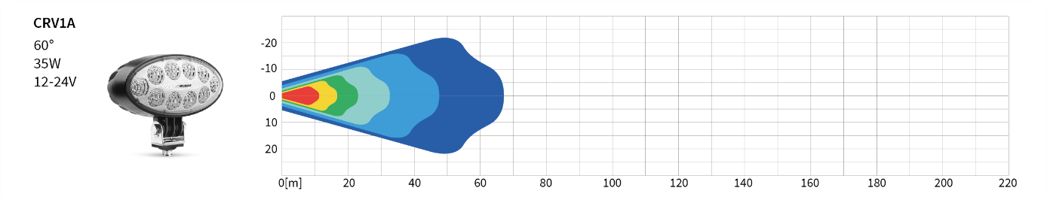

Work lamps producing a narrow light beam and emitting focused, directional light are another group of work lamps. These are installed when a vehicle is intended to move at a higher speed and the user needs illumination for a specific area far away from the vehicle. The lamps are also mounted on large machines to illuminate specific points at a great distance from the driver.

LED – a LED work lamp emitting focused light

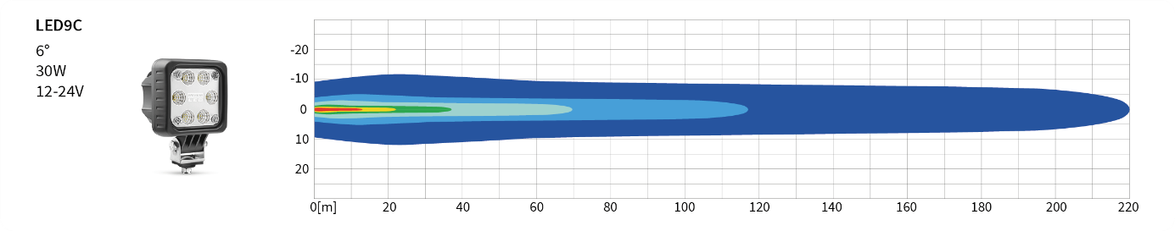
Lamps are selected according to the user's requirements to obtain optimum lighting effect for the work activities being carried out. Depending on the farming or construction vehicle on which lamps are to be mounted, it is LED work lamps with a wide light beam and mixed system lamps that are most often selected.
Now WESEM's product range has been expanded to include a new product – CRP2 LED work lamp. The design of the lamp incorporates a Combo light beam. The lamp, as it were, combines wide and narrow light beams into a single product. CRP2 lamps are installed in the recess underneath the vehicle cab roof, in the aim straight ahead position. The optical system of the lamp has been so designed that it emits a light beam slightly downwards (at 5° angle). As a result, uniform, optimum illumination is provided in front of the vehicle as well as over a short distance from the vehicle.

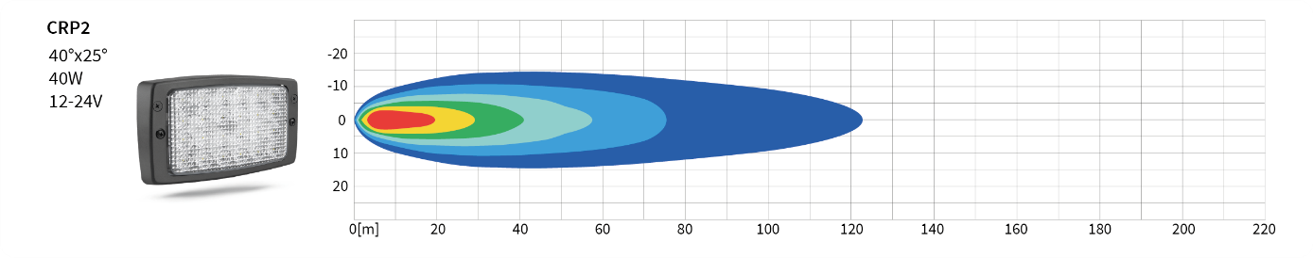

CRP2 lamps can be connected in two ways: with a lead and with a lead terminated with a Deutsch connector.

Popular lamp mounting configurations on vehicles include:
- One CRP2 LED work lamp on each side of a vehicle, underneath the roof;
- CRP2 LED work lamps – 2 pieces and headlights – 2 pieces (e.g. lights RE.21178 or PES1.41900, with approvals);
- A pair of CRP2 LED work lamps on each side of a vehicle.

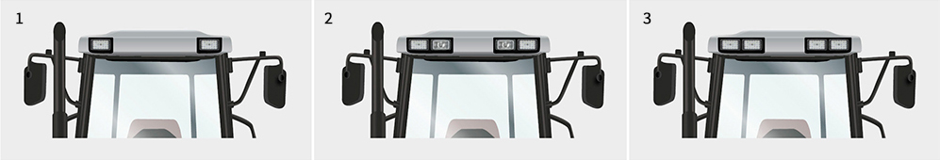

CRP2 lamps are a great alternative for halogen lamps.
They can be used on vehicles made by many popular manufacturers:
Fendt, Massey Ferguson, Case IH, Class, Deutz, Sampo, Steyr, Atlas Copco, Bomag, Caterpillar, Hamm, JCB, Komatsu, Liebherr, Terex.
They are also dedicated for vehicle manufacturers as OEM parts.

As required under WESEM's standards and quality policy, the new lamp is solid and durable, water- and dust-proof, and does not cause radio interference.

Press release: WESEM

Contact:
marketing@wesem.pl
---
WESEM is a Polish manufacturer of lighting for cars, agricultural vehicles and slow moving machines.
Products designed and manufactured in Poland combine modern design with the latest technical solutions. Understanding of customers' needs, own design studio, laboratory and production plants allow to keep high standard of the goods. Products are available on European, Asian and American markets for many years.

