Just drive and see everything with WESEM headlamps
Summer holidays are a time when we go away, often pursuing active recreation. If you choose to drive an off-road vehicle and want to enjoy off-roading, WESEM headlamps will come in handy when you need good illumination for both paved roads and difficult terrain. Take a look at our newest range of LED lamps that will make your journey safer and more pleasant.
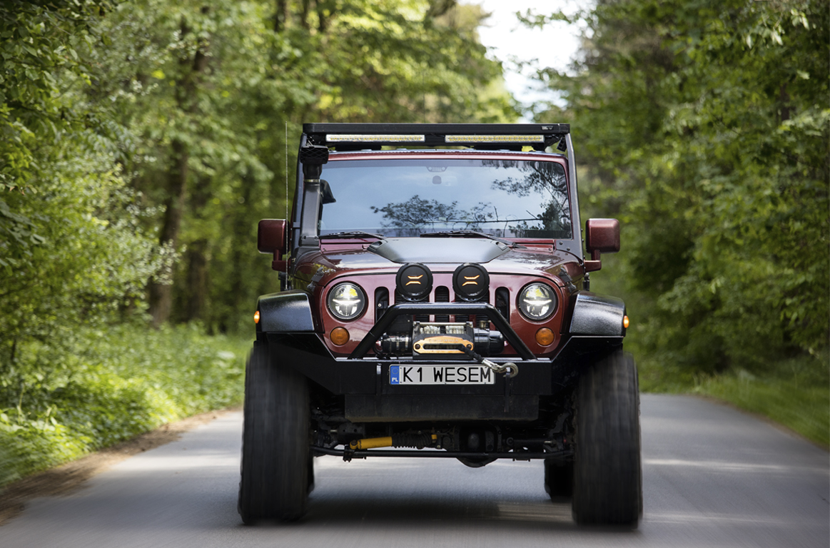
7-inch LED EGC1 headlamp
This is a substitute for many of the headlamps installed on popular brand off-road vehicles. This modern headlamp, with low power consumption, features 4 light functions: daytime running lights (DRL), low beams, high beams and position lights. It is available in popular 7” size and is easy to install. It holds European type approvals, which allows it to be used on public roads. In daytime, it catches your attention with the interesting shape of the daytime running lights, whereas at night it provides excellent visibility thanks to an option of simultaneous operation of high beams and low beams.
Product code: EGC1.55402
Additional LED FERVOR 180 driving lamps with a two-colour position light
These jaunty, sophisticated LED driving lamps are designed as additional equipment for off-road vehicles. Such a black driving lamp, with an orange position light on looks unique and catches the eye. Users preferring a more everyday appearance can switch the position light to white. These headlights do a great job when you are driving outside built-up areas and need to ensure extra illumination for the road ahead as well as maximum driving comfort. Advantages that cause drivers and enthusiasts to install these lamps include natural colour of driving light, energy saving properties, quality of workmanship as well as the competitive price.
Product code: LUM2.51281

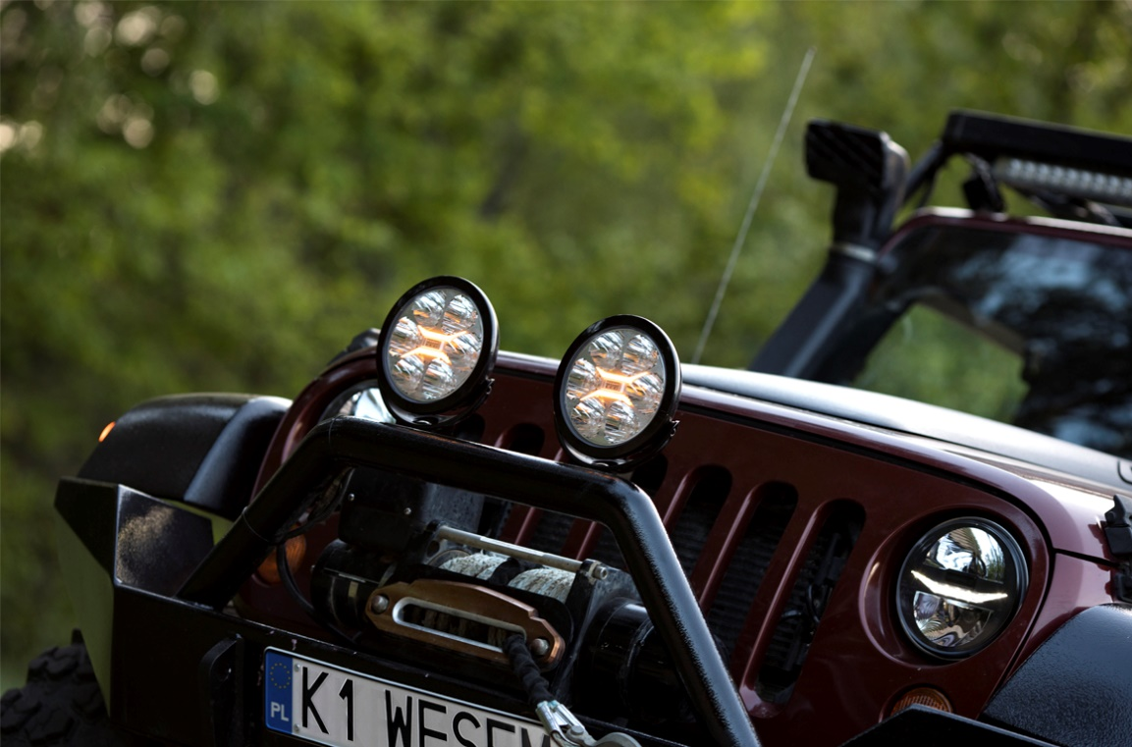

LED light bars with a position light - CDP1
LED BAR work lamps will soon be available for purchase. They are a great product for users who need to or like to have lots of lights in front of their vehicles - the lamps will come in versions with lumen output of 7000 - 13000 lm! Their size corresponds to that of a licence plate and they can be installed in ones or twos. Excellent light quality, modern appearance as well as multiple installation options (side, bottom or rear mount) will surely satisfy the most discriminating customers. A version with type approval has yet to be launched, but it is definitely worth waiting for.
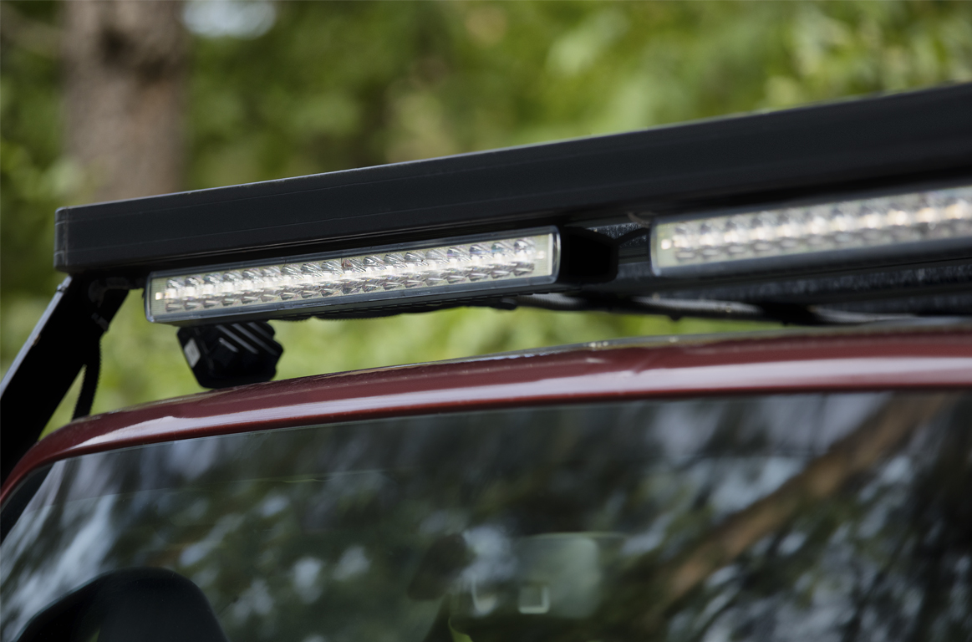
All WESEM lamps feature excellent quality of workmanship, durability and strength. They are fully hermetic and deliver good performance in all conditions. They are made of high quality materials in factories in Poland, with utmost attention to every detail and its functionality.

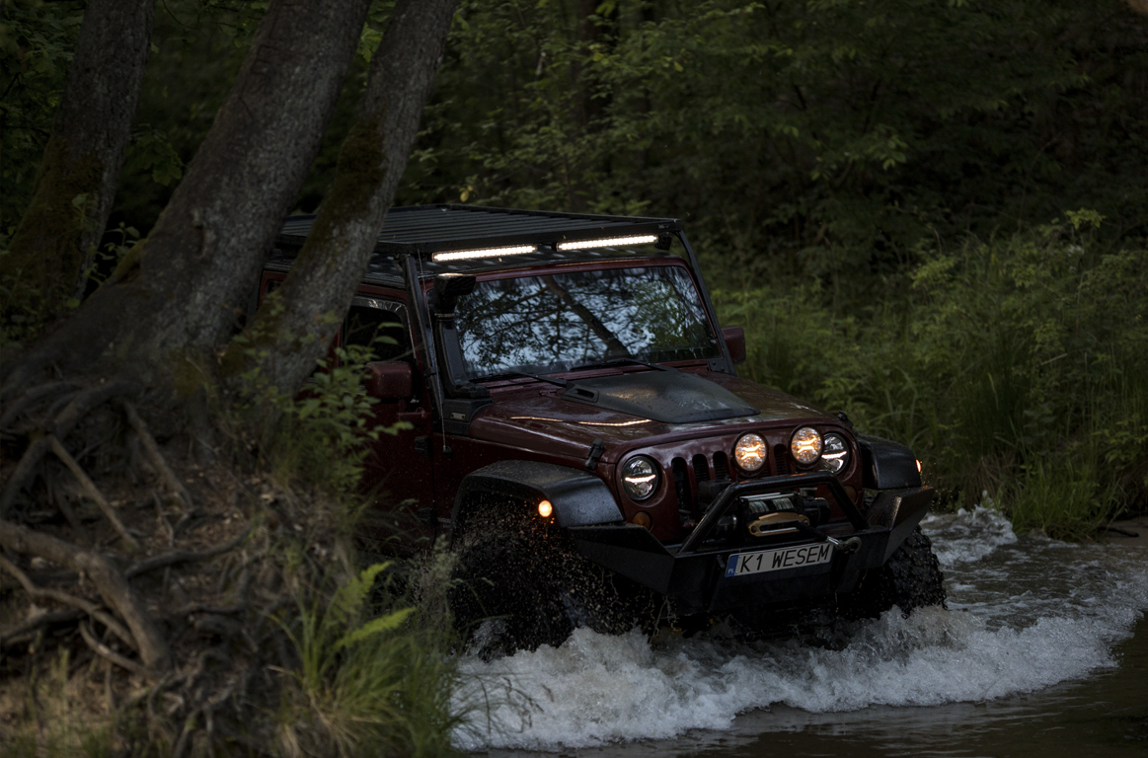
Press release: WESEM
---
WESEM is a Polish manufacturer of lighting for cars, agricultural vehicles and slow moving machines.
Products designed and manufactured in Poland combine modern design with the latest technical solutions. Understanding of customers' needs, own design studio, laboratory and production plants allow to keep high standard of the goods. Products are available on European, Asian and American markets for many years.

